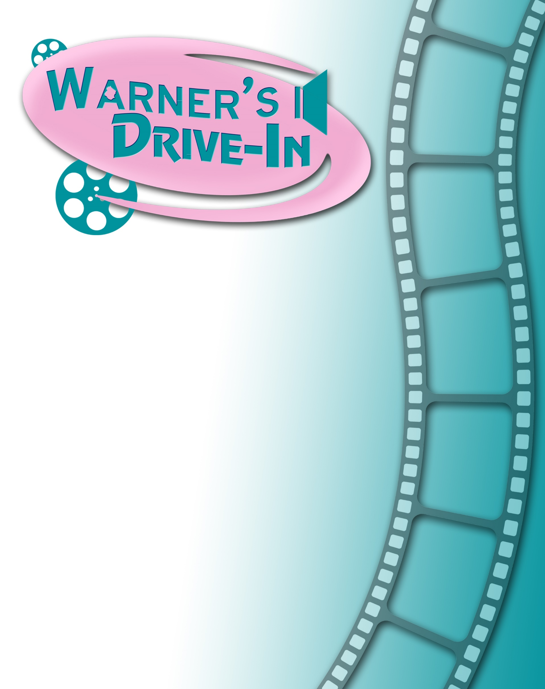

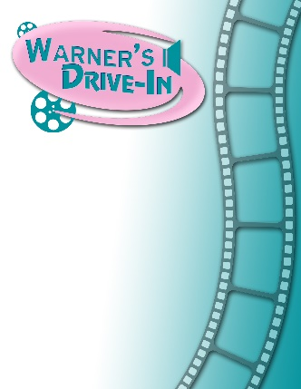
ADVERTISE WITH WARNER’S DRIVE-IN
in beautiful Pendleton County, WV

2026 SummerSeason!

Showing movies every weekend throughout the summer

Warner’s is the only drive-in theater in eastern West Virginia, and attracts patrons and drive-in enthusiasts from the Potomac Highlands, adjoining counties in Virginia, and as far away is Northern Virginia and Western Maryland.

Take advantage of this popular, safe, and growing venue to advertise your business!

Your advertising sponsorship will be part of a cherished community institution that specializes in affordable family fun and entertainment.

Warner’s is owned and operated by the Historic Warner’s Drive-In Cultural Resource Center. The Center is undertaking a major renovation of this historic landmark, with plans to extend the drive-in and provide facilities for live entertainment events.
See details on the reverse side!

Warner’s Drive-In Theater
2026 Movie Trailer Sponsorship Application
SPONSORSHIP LEVEL (check box or circle your preference)
Platinum Level — $1,000 for full season.
• 30-second video commercial plays before every movie*.
• Logo on back of flyers given out every week.
• Link on warnersdriveinwv.org to company website (for full year).
• Mention on Drive-In’s Facebook page
• Complementary movie tickets for you, your staff, or your patrons.

Gold Level — $500 for full season.
• Name and/or logo displayed individually on screen before every movie for 20 seconds.
• Logo on back of flyers given out every week.
• Link on warnersdriveinwv.org to company website for full year.
• Mention on Drive-In’s Facebook page

Silver Level — $250 for full season.
• Name and/or logo displayed individually on screen before every movie for 10 seconds.
• Company name on back of flyers given out every week.
• Link on warnersdriveinwv.org to company website for full year.
• Mention on Drive-In’s Facebook page

Bronze Level — $100 for full season.
• Name and/or logo displayed individually on screen before every movie for 5 seconds.
• Company name on back of flyers given out every week.
• Link on warnersdriveinwv.org to company website for full year.
• Mention on Drive-In’s Facebook page

_ _ _ _ _ _ _ _ _ _ _ _ _ _ _ _ _ _ _ _ _ _ _ _ _ _ _ _ _ _ _ _ _ _ _ _ _ _ _ _ _ _ _ _ _ _ _ _ _ _ _ _ _ _ _ _ _ _ _ _ _ _ _ _ _ _
Your Information:
Name as you would like it to appear in materials: ______________________________________________

Contact Person: _____________________________________ Title: ________________________________________

Billing Address: ____________________________________________________________________________________

_______________________________________________________________________________________________________

Phone:_______________________________ Email: _______________________________________________________

Website: ____________________________________________________________________________________________

Signed: ________________________________________________________________ Date: _______________________
Payment: Enclosed Paid Through PayPal DEADLINE MAY 1, 2026
Mail to: Warner’s Drive-In
P.O. Box 974 Franklin, WV 26807
For questions email: jbasagic@gmail.com

